Merchant Configuration Use Case

Submitted to

Alpha Payments Cloud


Tarang Software Technologies Private Limited
Tarang Towers,
#400/2, Whitefield 100 ft road,
Hoody circle,
Bangalore, India
Phone: +91-80-41157777
WEB: www.tarangtech.com

© This document is exclusive property of Tarang software Technologies Private Limited. No part of this may reproduced in any form without written permission.

Document Change History

Ver# | Editor | Date | Reviewer | Approver | Changes made
0.1 | Kailash Saita | 05th Sept 2012 | Bindu |  | Draft version
1.0 | Kailash Saita | 11th Sept 2012 | Bindu |  | Base version
1.01 | Kailash Saita | 25th Sept 2012 | Ronan |  | Updated version with Ronan’s review comments
1.02 | Kailash Saita | 28th Sept 2012 | Ronan |  | Updated with 27th review comments and added the search merchant and Commission use case in this document
Table of Contents
1 Introduction 4
2 Use Case: SEARCH Payment method Configuration 4
2.1 User Interface Information 5
2.1.1 User Interface details for search payment method configuration. 5
3 Use Case: Add Payment Method Configuration 5
3.1 User Interface Information 6
3.1.1 User Interface details for Add Payment Method Configuration 6
4 Use Case: Edit Payment Method Configuration 8
4.1 User Interface Information 8
4.1.1 User Interface details for Edit Payment Method Configuration 8
5 Use Case: DCC Configuration 9
5.1 User Interface Information 10
5.1.1 User Interface details for DCC Configuration 10
6 Use Case: SEARCH Merchant 10
6.1 User Interface Information 11
6.1.1 User Interface details for search Merchants 11
7 Use Case: commission configuration 12
7.1 User Interface Information 13
7.1.1 User Interface details for Merchant Commission Configuration 13

Introduction

This document describes all the use cases for Merchant Configuration. It includes two sections “Payment Method Configuration” and “DCC Configuration”.
In payment method configuration section- “Add/Edit Payment method Configuration” and “Search Criteria (ALL, INACTIVE, ACTIVE Status)”.
In DCC configuration section- This section will be display when Merchant configure for DCC on Merchant on-boarding.
Also Included the Search Merchant Use Case and Commission Use case

Use Case: SEARCH Payment method Configuration

Title | Search Payment Method Configuration
Requirement ID | RID-1119
Actors | System Admin, APC User with appropriate privilege.
Description | Actor should be able to search for the payment method based on Status.
Use case trigger | - Default ALL will be selected.  - Actor can select ACTIVE or INACTIVE Status.
Main flow / Flow of Events | - On selection of the criteria option from the main screen, system shall display the list of recently created 20 Payment Method Configure in creation date descending order which shall include the search criteria’s:“Status”.  - System shall build the query based on the criteria entered & retrieve the relevant records from the DB & display it in the listing in the below mentioned format: Payment Method, Auth Currency, Payment Type, Processor, Processor Merchant ID, Settlement Currency, Status, Created Date  - If multiple payment type is selected then it will display as “COMM SEPARATED”.
Sub-flow/Alternate Flows/ Scenarios | - If there are no matching records for the search criteria chosen; system should display an appropriate message saying “No Records found.”  - Depending on the status criteria chose, Active/Inactive only payment methods for the merchant in the respective status should be retrieved.  - If the actor selects the row and clicks on edit link at the bottom of the table, system should navigate the actor to the corresponding bank edit screen. This feature will be detailed out as part of separate use case.  - If the actor clicks on the “Add” link at the bottom of the table, system should navigate the actor to the Add Payment Method screen. This feature will detailed out as part of separate use case.
Assumptions | -
Pre-conditions | Actor should be logged into the system & has the appropriate privilege. Default Search is “ALL”
Post-conditions | - Actor is able to retrieve the relevant payment method records from the system based on the search criteria chosen.
Status | Open
Issues
Business Rules | Search – Query should be search. I.e. status = “ACTIVE” OR status=”INACTIVE”. Or Status=”All”  The configuration header label will highlight the merchant business name and MID for the selected merchant  eg: Configuration : Merchant - Retail (MID-APC12345)

User Interface Information

User Interface details for search payment method configuration.

Refer the payment method configuration screen in the merchant list of the storyboard.

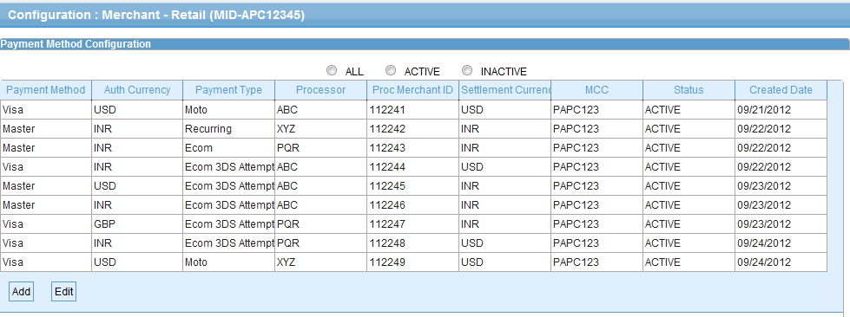

Validations for Search Payment Method Configuration

Id | Parameter Name | Field Type | Special characters | Validations | Field Length | Possible Values | Additional Condition | Mandatory
1 | Status | Radio Button |  |  |  | All, Active, Inactive

Use Case: Add Payment Method Configuration

Title | Add Payment Method Configuration
Requirement ID | RID-1120
Actors | System Admin, APC User with appropriate privilege to Add Payment Method Configuration for the merchant
Description | Allows the actor to add a Payment Method Configuration.
Use case trigger | - Actor chooses to click on “Add” link/button from the Configuration screen (Payment Method Configuration section)
Main flow / Flow of Events | - System shall navigate the actor to the Add Payment Method Configuration screen along with the following fields to be captured.  - Details of the fields shown are:  - Processor,  - Payment Method,  - Auth Currency  - Settlement Currency  - Processor Merchant ID  - Config ID  - MCC  - Payment Type{Ecom, Recurring, Moto, Ecom 3DS Auth, Ecom 3DS Attempted}  - Status.(Default is Active)  - Actor shall enter the relevant information list & Click on Add To List.  - Then Actor can perform more add and finally actor will save all the relevant information into the system. It works as bulk save.
Sub-flow/Alternate Flows/ Scenarios | 4a. If the actor enters the invalid data, the Actor shall be navigated to the same screen with appropriate error message.
Assumptions | None
Pre-conditions | The actor is logged in to the application.  - In Selection of processor, payment method will be filter.  - Auth and settlement Currency will be filtered based on “Processor and Payment Method”
Post-conditions | - Add – Payment method configuration will successfully be created in the system and the Actor will be navigated to the Configuration listing screen with the newly created Payment method details.
Status | Open
Issues
Business Rules | Processor, Payment Method, Auth Currency, Settlement Currency, and Processor Merchant ID will be Unique for the merchant.  Processor Merchant ID shall not be unique per currency as this is dependent on the processor business rule, This can be the same processor Merchant Id for the Auth currency of a merchant  Processor Merchant ID will be generated and passed by processor for each payment method and payment type  Status will be Active by default and is non editable in add screen  Config ID will be a long field and it may be structured for other payment methods e.g. having prefixes such as bank code as part of the stored data element. The field will allow for the Label along with the configuration value as entry.

User Interface Information

User Interface details for Add Payment Method Configuration

Refer “Add Payment Method configuration” screen of the storyboard
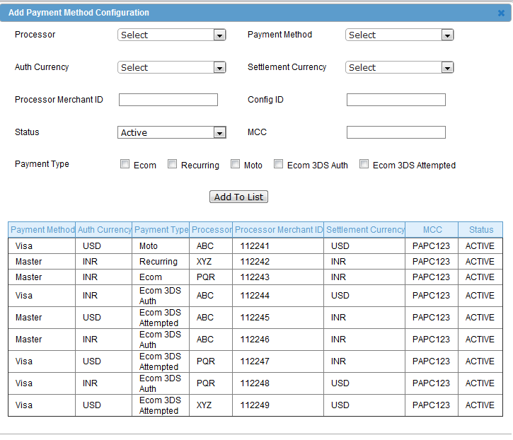

Validations for Add Payment Method Configuration

Id | Parameter Name | Field Type | Special characters | Validations | Field Length | Possible Values | Additional Condition | Mandatory
 | Processor | Drop down
 | Payment Method | Drop down
 | Auth Currency | Drop down
 | Settlement Currency | Droo down
 | Processor Merchant ID | Text box |  |  |  | Generated and shared by processor
 | Config ID | Text box |  |  |  | --
 | Status | Drop down |  | Read only |  | Default to Active
 | MCC | Text box
 | Payment Type | Check box |  |  |  | Ecom, Recurring, Moto, Ecom 3DS Auth, Ecom 3DS Attempted

Use Case: Edit Payment Method Configuration

Title | Edit Payment Method Configuration
Requirement ID | RID-1121
Actors | System Admin, APC User with appropriate privilege to Edit Payment Method Configuration
Description | Allows the Actor to Edit Payment Method Configuration details
Use case trigger | - Actor selects the row from the Payment Method Configuration section listing grid and clicks on the Edit link at the bottom of the table
Main flow / Flow of Events | System shall navigate the actor to the Edit Payment Method Configuration screen along with the following fields to be updated.  details of the fields with the existing values shown are:  - Processor,  - Payment Method,  - Auth Currency  - Settlement Currency  - Processor Merchant ID  - MCC  - Payment Type{Ecom, Recurring, Moto, Ecom 3DS Auth, Ecom 3DS Attempted}  - Status.  Actor need to select the below list and update the relevant information and click on Add To List.  Actor can click on save to update the information into the DB.
Sub-flow/Alternate Flows/ Scenarios | If the Actor enters the invalid data, the Actor shall be navigated to the same screen with appropriate error message.
Assumptions
Pre-conditions | Actor is logged into the system with appropriate privilege.
Post-conditions | The fields which are modified will be updated in the DB and the Actor will be navigated to the Configuration listing screen with the updated Payment method details.
Status | Open
Issues | None
Business Rules | Processor, Payment Method, Auth Currency, Settlement Currency, and Processor Merchant ID is Unique.  MCC value will be default value captured in add merchant screen, user can edit value for each payment method

User Interface Information

User Interface details for Edit Payment Method Configuration

Refer “Add Payment Method configuration” screen of the storyboard
Same as add screen

Validations for Edit Payment Method Configuration

Id | Parameter Name | Field Type | Special characters | Validations | Field Length | Possible Values | Additional Condition | Mandatory
 | Processor | Drop down
 | Payment Method | Drop down
 | Auth Currency | Drop down
 | Settlement Currency | Droo down
 | Processor Merchant ID | Text box |  | Read only |  | Generated and shared by processor
 | Config ID | Text box |  |  |  | Bank A/c for certain payment method
 | Status | Drop down
 | MCC | Text box
 | Payment Type | Check box |  |  |  | Ecom, Recurring, Moto, Ecom 3DS Auth, Ecom 3DS Attempted

Use Case: DCC Configuration

Title | DCC Configuration
Requirement ID | RID-1122
Actors | System Admin, APC User with appropriate privilege Configuration
Description | Allows the Actor to add/edit DCC Configuration details.
Use case trigger | Actor need to select the payment method for DCC Config.
Main flow / Flow of Events | Actors select multiple payment method need to configure for DCC.  Actor clicks on Save to store the information into the DB.  .
Sub-flow/Alternate Flows/ Scenarios | None
Assumptions
Pre-conditions | Actor is logged into the system with appropriate privilege and merchant configure for DCC then only DCC Configuration Section will be displayed.  System will display all the payment method which is configured for the merchant.
Post-conditions | Configure the DCC configuration for the merchant
Status | Open
Issues | None
Business Rules | DCC will be supported only for payment method – Visa and Master

User Interface Information

User Interface details for DCC Configuration

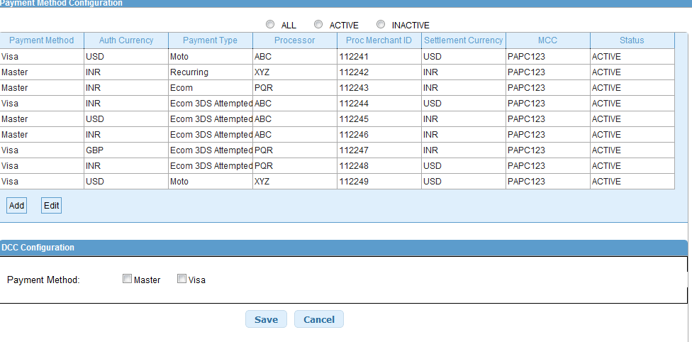

Validations for DCC Configuration

Will be updated later

Use Case: SEARCH Merchant

Title | Search Merchant
Requirement ID | RID-1111
Actors | APC User with appropriate privilege
Description | Actor should be able to search for the merchant
Use case trigger | - When Actor selects the “Manage Merchant” option from the main menu to search/view Merchant List
Main flow / Flow of Events | - On selecting the “Manage Merchant “option from the main menu, system navigates to screen which display the list of Merchant in APC.  - Actor shall enter the search criteria & click on “Search” button.  Search criteria’s :  Business Name,  Country,  Status.  - System shall build the query based on the criteria entered & retrieve the relevant records from the DB & display it in the listing in the below mentioned format:  [MID, Business Name, Contact Person, Contact No, Approval Status, Country]
Sub-flow/Alternate Flows/ Scenarios | 2a. If the actor does not choose to enter any data in the search criteria’s then the system shall retrieve all the Merchant records.  2b. If there are no relevant records for the search criteria chosen; system should display an appropriate message saying “No Records found.”
Assumptions | -
Pre-conditions | Actor should be logged into the system & has the appropriate privilege to manage Merchants.
Post-conditions | - Actor is able to retrieve the relevant Merchant records from the system based on the search criteria chosen.
Status | Open
Issues
Business Rules | Search – Query should be for partial search. I.e. like “%string%”. So the minimal search keys that you enter should retrieve the maximum information. For ex: Search By Business Name – “C” should retrieve the entire Merchant with the alphabet “c” in their names.

User Interface Information

User Interface details for search Merchants

Refer the Manage Merchant screen of the storyboard
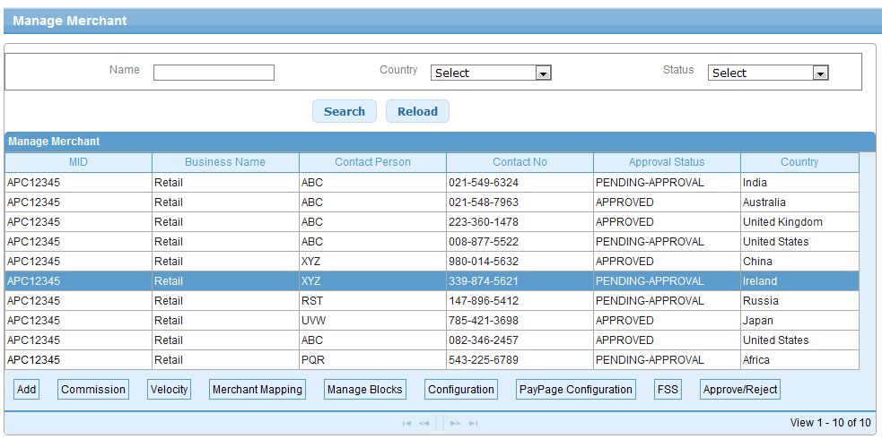

Validations for Search Merchant

Id | Parameter Name | Field Type | Special characters | Validations | Field Length | Possible Values | Additional Condition | Mandatory
 | Name | Textbox |  |  |  | Merchant Business name
 | Country | Drop down
 | Status | Drop down |  |  |  | All Merchant/Approved Merchant/Pending Approval Merchant

Use Case: commission configuration

Title | Commission Configuration
Requirement ID | RID-1129
Actors | APC User with appropriate privilege to edit the commission configuration for a merchant
Description | Commission configuration for a Merchant in APC System
Use case trigger | - Actor selects the 'Commission' from “Manage Merchant” screen.
Main flow / Flow of Events | - On selection of 'Commission' button, for a selected merchant APC System navigates to 'Merchant Commission' screen.  - Actor has to provide input for the fields as below:  Simple[Commission(%)/Flat Commission/Both]  Transaction amount slab/Daily transaction amount slab  [Start Range, End Range, Condition(both),/Commission(%)/Flat Commission]  - After providing the related input values to above configuration fields, Actor selects 'Save' button to persist the configuration associated with the Merchant in DB or 'Cancel' for cancel the current flow and go back to 'Manage Merchant' screen.
Sub-flow/Alternate Flows/ Scenarios | 2a. Actor can select either one of the given type for commission like:  Simple/ Transaction amount slab/Daily transaction amount slab.  2b. If Actor selects 'Simple', configuration input needed as:  Commission (%)  Flat Commission  Both  2c If Actor selects 'Transaction amount slab/Daily transaction amount slab' , configuration  input needed as:  Start Range –  End Range  Condition(both)  Commission (%)  Flat Commission
Assumptions
Pre-conditions | Actor should be logged into the system & has the appropriate privilege to manage commission for a merchant.
Post-conditions | - Commission configuration will be associated to Merchant
Status | Open
Issues | None
Business Rules | - Actor can select either one of the given type for commission like:  Simple/ Transaction amount slab/Daily transaction amount slab.  And it will be applicable on per transaction basis.  - If Actor selects 'Simple', configuration input needed as:  Commission(%) - Given percentage of transaction amount will be applicable  Flat Commission – Given amount will be applicable on the transaction  Both – Commission(%) + Flat commission will be applicable  - If Actor selects 'Transaction amount slab/Daily transaction amount slab' , configuration  input needed as:  Start Range –  End Range  Condition(both)  Commission (%)  Flat Commission  - Transaction amount slab – Commission will be applicable on Per transaction basis  - Daily transaction amount slab – Commission will be applicable on slab basis on cumulative transactions for the day.  - No. of slabs is restricted to 3.

User Interface Information

User Interface details for Merchant Commission Configuration

Refer the Commission page of the storyboard

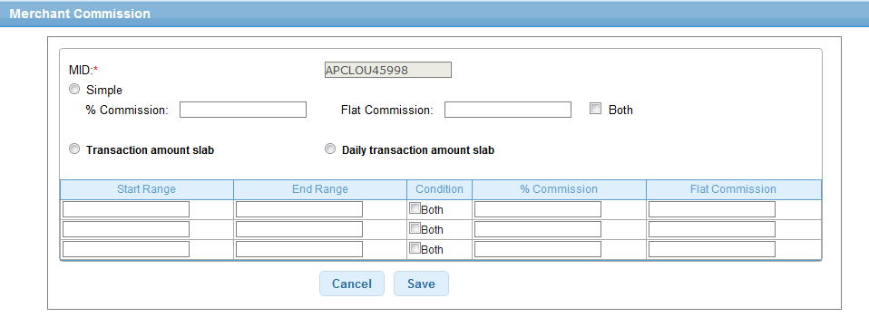

Validations

Will be updated later

